Heart disease prediction using different Machine learning methods and Deep learning Algorithms

3.1. Data set Used
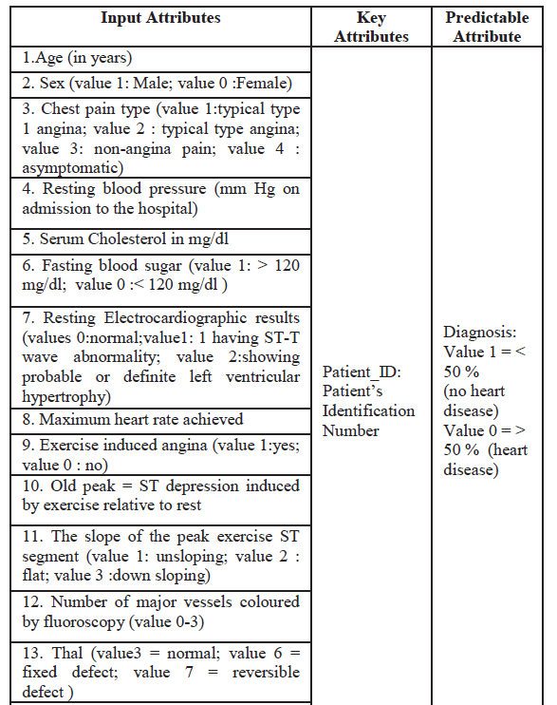
DECISION TREE
It's a tree-like model to make predictions, and it shows an upside-down tree, i.e., it splits the data into multiple sets of data. Each set is further divided into subsets to arrive at a decision finally. It works on nested if then else structure, i.e., each node divides the data into either left or right direction. The top node in the decision tree is called the root node, the node can be classified into a leaf node, and the intermediate nodes between the root and the leaf nodes are called internal nodes.
We imported the required libraries to analyze data, to build the predictive model using different techniques like logistic regression, linear regression, etc. some of the libraries used are NumPy, pandas, math, random, seaborn, and matplot lib.pyplot are used for data analytics or exploratory data analytics [EDA]
For preprocessing the data, the model building we used is SCIKIT-learn which has standard scalar, MinMaxScalar, and Robust scalar to scale down the values in the dataset to between o and 1. The standard scalar makes the dataset value around 0.
Typically any dataset is classified into training and testing, with respect to division ratio, 70:30, 70 % of the data is used for training, and the remaining 30% is used for testing. With the help of pandas library, the excel sheet data is imported into phyton language, later the duplicates in the data are removed using drop_duplicates syntax with considering all the features, later the data is readable and converted or stored into DF data form, or DF. Shape.
Table 2. Features imported into DF dataform.
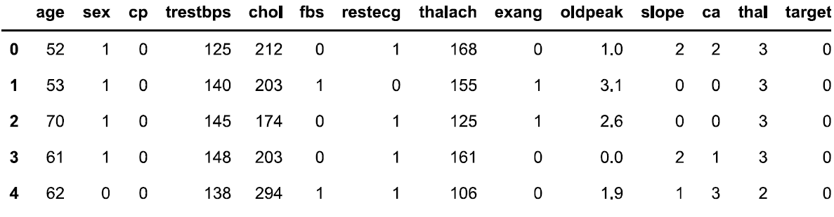

Basically, in the UCI repository, the data set has 1024x 14 rows and columns, i.e., 1024 patients with 14 features are considered in our proposed system, with duplicates. Later the data is cleaned i.e., and we have removed the duplicates the matrix size is converted to 302x14. In the decision tree-based algorithm, the data is divided into X and Y, i.e., the Y terminal has 302x1 matrix values, i.e., 302 patients with one target value. Similarly, the X terminal has 302x13 matrix values, i.e., 302 patients with 13 features expect target variables. All the features are shown in table 1. With the help of skik learn and imported train test split the data into 0.70 and 0.30, i.e., train_size=0.7 and test_size is 0.3, i.e., the training dataset is 70%, and the testing dataset is 30%. After splitting the data, X_training becomes 211x13 matrix size. Similarly, X_test becomes 91x13 matrix size. Again, Y_train is converted to 211x1 matrix size, and X_train is converted to 91x1 matrix size. After setting up the data, the data is fitted into the algorithm, the decision tree classifier with Instantiate with a maximum depth of 3, i.e. X_train and Y_train, is fitted into the classifier. With the help of phy.plus and Graphviz libraries, the classifier is plotted in figure 1.
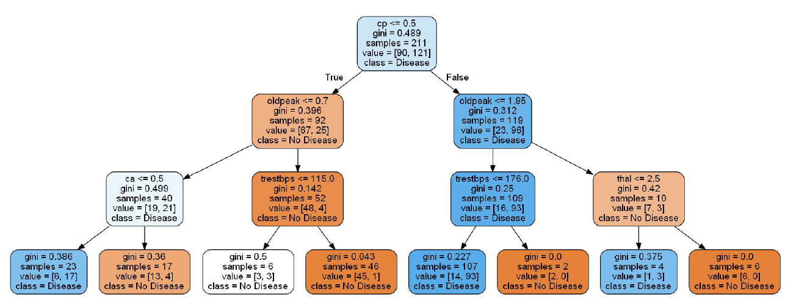
Figure 1.
In figure 1, the last stage is tree leaves. After importing the confusion matrix, the accuracy is only 86%, i.e., true values are 86%, and false values are 14%. This build or prediction model didn't predict the accurate answer.
Confusion matrix
A confusion matrix is a technique for summarizing the performance of a classification algorithm. Classification accuracy alone can be misleading if you have an unequal number of observations in each class or if you have more than two classes in your dataset.
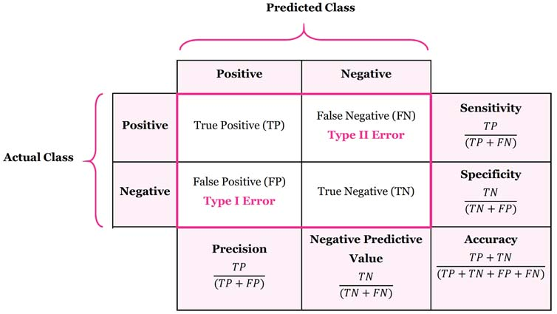
Figure 2. Confusion matrix

The confusion matrix output is
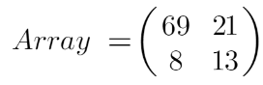 (1)
Accuracy can be calculated as the ratio of correctly predicted labels to the total number of labels, the training accuracy is 86.25%, and the testing accuracy is 76.92% which is not reliable. This model is not efficient, so we have gone for hyperparameter tuning.

